Senior Design Project Proposal

Secondary Design Project: Camera Positioning System Location and Orientation Controller
(CaPSLOC)

Curtis Hendrix
Michael Ludwig
Jonathan Proch
Edwin Sarver

Needs (CH)
Before it is approved for use in mission-critical environments and situations, military technology must undergo substantial field testing. One such technology is that of infrared imaging and other sensing technologies, along with their data processing algorithms. In the course of these tests, human error becomes a factor, as the test team must manually position the cameras to view various targets. It would be preferable to have a system by which the cameras could be automatically positioned, allowing the tester team to focus on the more important parts of their jobs.

Objective (JP)
This project aims to create a system by which infrared cameras will be automatically positioned and controlled according to a pre-defined (but configurable) testing script. The control device will allow for full control of the camera, including elevation, orientation, and control of the image capture mechanism. The device will also be capable of detecting its own position and orientation, in order to locate the target coordinates as a relative position.

Research Survey (CH, JP)
The US military extensively uses infrared cameras, and develops new imaging technology and algorithms, and these require long and tedious tedious testing. Automation is needed to test the new technologies to reduce stress on testing teams, and to increase test repeatability. Test stands are used to aim the Device Under Test (DUT) at various infrared targets, and record the images produced by the DUT. Current systems already exist, but are expensive. The Air Force is looking for a cheaper solution, by utilizing an Android phone as the control hub and primary sensor platform of a camera test stand [1].

The Air Force is seeking a cheap, programmable camera positioning test stand, capable of supporting a 30lb DUT. The test stand needs to be programmable with a test script, that defines where the camera should be pointed, for a specified time span. The stand needs to be able to swing 360 degrees laterally, and pan 90 degrees vertically. In addition, the stand should be able to function inverted, in order to acquire targets that are below the horizon. Also, the stand needs to be able to trigger the DUT to capture an image, and be able to take a visible light image as well, to verify the target [1].

The basic idea behind this test stand is rather simple. By knowing where the test stand is, which way it's pointing, and where the targets are in space, the stand can aim the DUT at the target. As simplified illustration of this is shown in Figure 1 and Figure 2. Figure 1 shows the test stand and the target on the X Y plane. Figure 2 shows the test stand and target on the X Z plane. The X Y plane defines where on a surface a specific point is, and the X Z plane defines how far off the X Y plane that point is. The X Y Z coordinates can define every single point in 3 dimensional space.
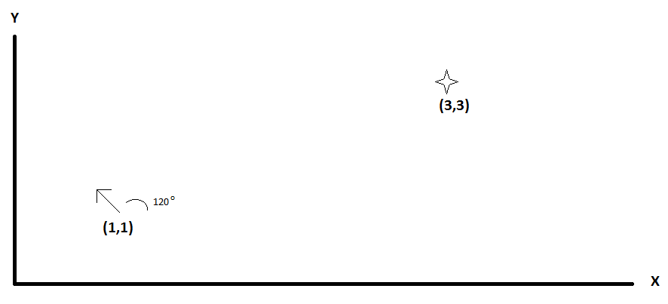
Figure 1. Simplified diagram showing test stand at (1,1), represented by the arrow, and the target at (3,3), represented by the star.

Simple trigonometry can be used to determine the angle between the two points, as shown in Equation 1. Taking the arc-tangent of the Y X ratio will reveal the angle from the origin to the point. By subtracting the corresponding X and Y coordinates from 2 points, the angle between those can be found by using the arc-tangent. Using Figure 1 as an example, the test stand (1,1) would be subtracted from the target (3,3). This gives the coordinates of the target, relative to the test stand, rather than relative to the origin. In this case, the relative coordinates for the target would be (2,2). Plugging X=2, Y=2 into Equation 1 yields an angle of 45º.
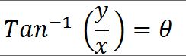
1.

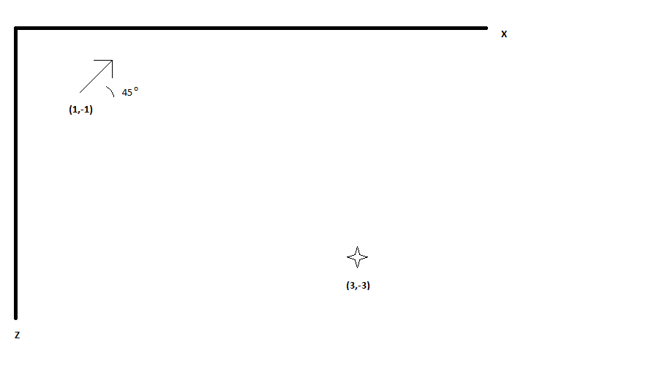
Figure 2. Simplified diagram showing the test stand at (1,-1), represented by an arrow, and the target at (3,-3), represented by the star.

This means that the test stand needs to swing to 45º off the X axis in order to point to the target. The same principle holds true for determining the elevation angle of the test stand. Using Figure 2 as an example, the test stand coordinates are subtracted from the target, giving a relative target coordinate of (2,-2). Plugging into Equation 1 yields an elevation angle of -45º.

This high school level model looks all well and good, but how is this going to be realized in the real world? First, the system needs a way of determining where it is. The most obvious choice is GPS, or Global Positioning System. The actual implementation of this system is rather complicated, but essentially, it allows every point on earth to be mapped to a unique point on the Geographic Coordinate System [2]. The Earth is divided into 4 hemispheres: North, South, East, and West. The North and South are divided along the Equator, and the East and West are divided along the Prime Meridian and 180º longitude, as shown in Figure 3. The GCS uses Longitude to describe the angle between the Equator, and a point on Earth. For example, the North Pole is at 90º Latitude. Latitude, on the other hand, describes the angle between the Prime Meridian, and a point on Earth. For further resolution, the angles are further divided into minutes and seconds. Like the clock use, there are 60 seconds in a minute, and 60 minutes in a degree. By using GPS, one can know the location of any point on Earth, to within a few meters [2].

By equipping the test stand with a GPS receiver, and programming the GCS coordinates of the targets in the test script, it's very simple to determine the relative locations of everything on the X Y plane. However, elevation is a bit more difficult to realize. GPS does provide an elevation reading, but the tolerance of this can be quite poor, on the order of +/- 15 meters, or even more [3]. This may prove to be usable, but will depend on the relative spacing of the targets and test stand in the X Z plane. If they are hundreds or thousands of feet apart on the Z axis, then altitude measurement with GPS may prove usable. If the spacing is less, however, a different system must be used.

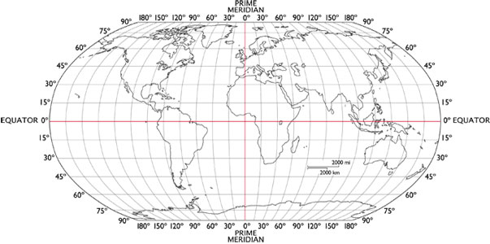
Figure 3. Longitude and Latitude on the Earth.

The unit will also need to be able to detect which way it is facing, and at what angle from the ground. Detecting the angle is relatively simple. An accelerometer, as implied by its name, measures acceleration. Specifically, the acceleration due to gravity. Most accelerometers are 3 axis, meaning they are sensitive in the X, Y, and Z planes. By using a 3 axis sensing, the pitch, roll, and inclination can be found [7]. However, this project requires only pitch; the angle of X-axis. By utilizing 2 axis of the accelerometer, the pitch can be easily and accurately found. Consider Figure 4 as a simple example. The X and Y axis are relative to the test stand. Conceptually, think of the IR camera under test as facing parallel with the X axis. If the test stand was level, the X axis would be parallel to the ground, and the Y axis would be pointing straight up. But that's not the case in Figure 4. Here, the test stand has been elevated by some angle, θ. Basic Trigonometry says that the angle from the X axis to level is the same as the angle from the Y axis to vertical (the pull of gravity). The accelerometer will deliver magnitude values for Y and X. Gravity is also known, at 9.86 m/s², but isn't needed for the actual angle calculation. The ratio of the lengths of X and Y can be found from Equation 2 [7].
Equation 2. Ratio representation of X and Y.

Taking the inverse tangent of both sides yields Equation 3, which delivers a very simple method of determining the pitch angle.
Equation 3. Angle as a function of the X and Y ratio.
In addition, the error can be easily calculated. Solving the Pythagorean Theorem for the hypotenuse (Gravity, in this case), yields Equation 4. Assuming the X and Y measurements are very close to their theoretical values, then G in Equation 4 should be very close to the known Gravity Constant.

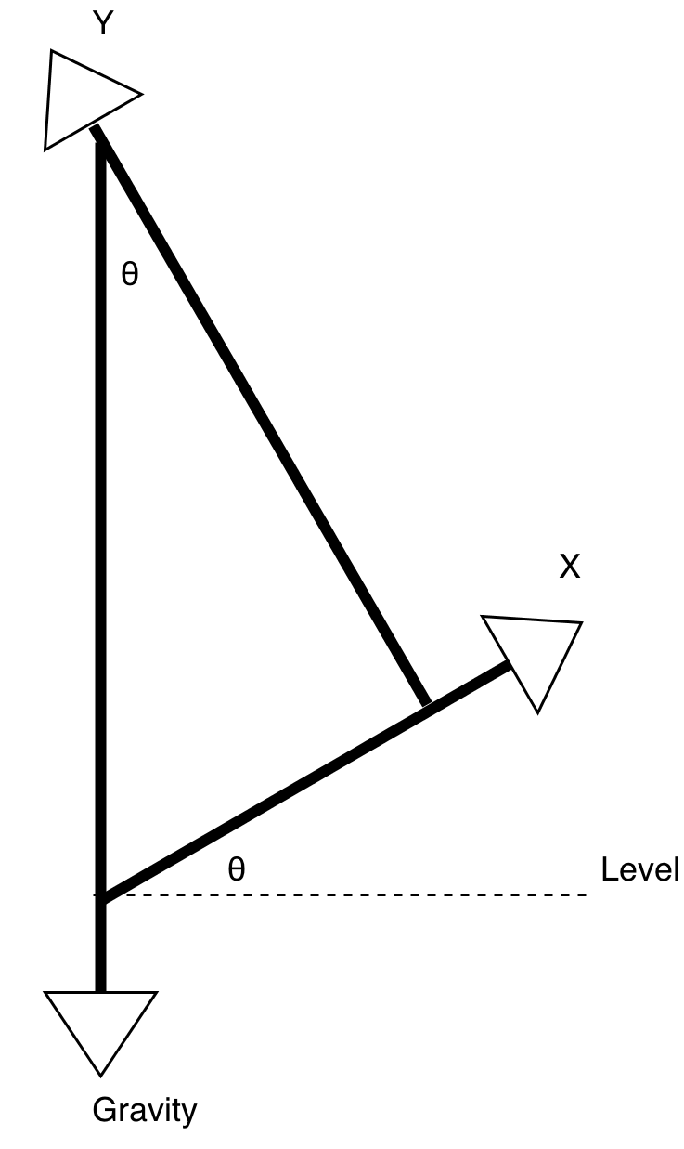

Figure 4. Simple triangle formed by the X and Y axis, and gravity.

Equation 4. Pythagorean theorem solved for the hypotenuse.

The next problem to solve is determining which way the test stand is facing. The angle of elevation can be found from the above technique, but another sensor is needed to determine the facing direction. This requires the use of a magnetometer, in order to detect the earth's magnetic field [8]. If the test stand remained flat, then the direction could be calculated from the arc-tangent of the two horizontal magnetic fields. However, this will not always be the case, and the test stand needs to take this into consideration. Fortunately, Freescale Semiconductor has provided a very simple, easy-to-follow guide to create a compass using magnetometers and accelerometers [8].

As stated above, current test stands used by the Air Force are already implemented, but are expensive. A new solution is being sought that will reduce the cost. The Air Force believes that by using an Android Phone, which already has all the sensors and software needed for determining position and direction, much of the cost of the test stand can be eliminated [1].

As this is a college project proposal, put out by the Air Force, other student teams from other universities have attempted this project. One team consisted of 5 engineering students from Michigan State University [4]. They followed the Air Force's suggestion of using an Android Phone as the main controller of their system. While they did build a system that worked, it had a few major problems. First, the sensors in the phone did not provide the resolution needed to accurately position the test stand, particularly the accelerometers. GPS positioning was also difficult indoors, but that is due to the limitations of GPS in general, not the phone. In particular, the magnetometer and accelerometers were not sensitive enough to provide accurate positioning. In addition, the test stand required a laptop to send the capture signal to the infrared camera. This added bulk and complexity to the design. [5]

Therefore, the Android Camera will be abandoned, and replaced with a more embedded design. The Air Force has allowed for this flexibility in the problem statement, stating “In considering options to optimize cost versus performance, the student team is free to investigate and propose an alternate solution to this problem” [1]. This approach will allow for a focused hardware design, eliminating much of the problems encountered by the Michigan Statue Univeristy design team. The control logic and hardware is relatively simple to implement, but the visible image capture system requires beefier hardware, in order to provide compression and transmission. The basic idea is to use a sub-micro computer, like a Raspberry Pi, as the root the test stand. The Raspberry Pi is a very small computer, about the size of a credit card, but has most of the capability of a desktop computer [6]. The Raspberry Pi will allow the test stand to be very flexible in terms of additional connectivity and features. For example, it could be possible to enable WiFi connectivity to each test stand, and allow a central operator to independently control and interact with multiple test stands. This also elimates the cost of a phone, which can be $200 or more [5]. The cost of a Raspberry Pi, on the other hand is approximately $65 [6].

Marketing Requirements (CH, ML, JP, ES)
- A motorized control mount should be provided to be used for camera testing
- Control mount should allow for complete range of camera motion within one hemisphere
- Control mount should allow for the Android device to be placed in the needed orientation for sensor functionality
- Mount should be able to hold the camera without modifications to the camera body
- System should be able to be scripted for tests.
- Scripting should be as simple as possible, without sacrificing needed functionality.
- Scripting should be able to be done in a well-defined, clearly documented format
- Scripting should provide full remote control of the camera
- The system should provide capabilities for the collection of all necessary data
- System should be able to provide basic context data (time, coords, etc.)
- The test stand should provide a visible light image of what the IR camera sees.

Objective Tree (CH, ML, JP, ES)

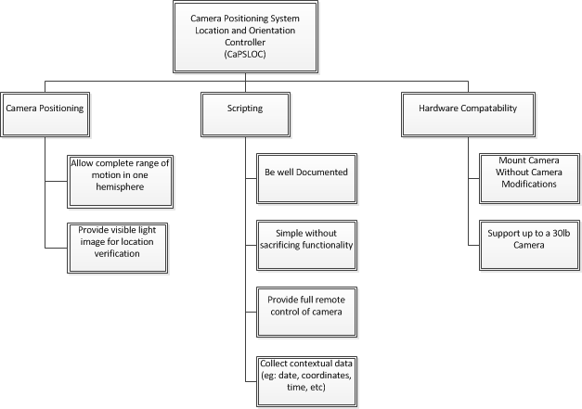

Level 0 Block Diagram (CH, ML, JP, ES)
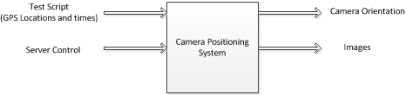

Module | CaPSLOC
Inputs | - Test Script: Orientation and time instructions  - Server Control: Control instructions from the central control operator
Outputs | - Camera Orientation: Positions the test stand according to instructions from the Test Script.  - Images: Visible light images taken for position verification
Functionality | Provide an automated infrared camera positioning system, used for testing new cameras and algorithms, and captures visible light images, used for verification of target.

Design Team Information

Name | Major | ESI
Curtis Hendrix | Computer Engineering | Y
Michael Ludwig | Electrical Engineering | Y
Jonathan Proch | Computer Engineering | Y
Edwin Sarver | Computer Engineering | Y

References

[1] Android Enabled Programmable Camera Positioning System, [Microsoft Office Word]. Available:
http://www.afrlstudentchallenge.org/AFRLCapstone.nsf/cps/618916D4400D3B308525795D0076BFC5/$FILE/AndroidEnabledProgrammableCameraPositioningSystem.docx

[2] J. Riesterer. (2008, April 7). Geographic Coordinate System [Online]. Available: http://geology.isu.edu/geostac/Field_Exercise/topomaps/grid_assign.htm

[3] J. Mehaffey (2001, February 1). Gps Altidude Readout > How Accurate? [Online]. Available: http://gpsinformation.net/main/altitude.htm

[4] A. Fletcher et al. (2012, February 2). Android Enabled Programmable Camera Positioning System. Sponsor: Air Force Research Laboratory. Pre-Proposal. [PDF]. Available:
http://www.egr.msu.edu/classes/ece480/capstone/spring12/group03/Documents/480Pre-proposal.pdf

[5] A. Fletcher et. al. (2012, April 25). Android-Enabled Programmable Camera Positioning System. [Online]. Available:
http://www.egr.msu.edu/classes/ece480/capstone/spring12/group03/Documents/FinalReport.pdf

[6] FAQs [Online]. Available: http://www.raspberrypi.org/faqs

[7] K. Tuck. (June 2007). Tilt Sensing using Linerar Accelerometers [PDF]. Available: http://www.mh-hannover.de/fileadmin/zentrale_einrichtungen/zentrale_forschungswerkst/downloads/AN3461.pdf

[8] T. Ozyagcilar (January 2012). Implementing a Tilt-Complensated eCompass using Accelerometers and Magnetometer Sensors. [PDF]. Available:
http://www.freescale.com/files/sensors/doc/app_note/AN4248.pdf

